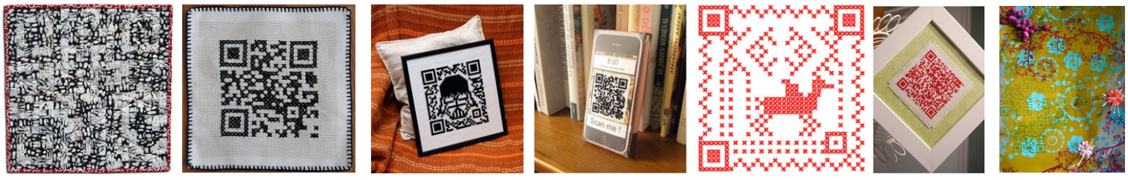
PRESS RELEASE 01.06.11
For immediate release
The QR-3D Project
“Make, share and exhibit textile QR codes”
www.qr-3d.weebly.com
QR-3D is an invitation to anyone, anywhere in the world to make, share and have the chance to exhibit a textile QR code.
QR codes are traditionally a two-dimensional device used by barcode readers and camera phones consisting of smaller black squares on a larger square white background. The information contained within usually direct code readers to a website, but can also be used to hide text messages or other information.
After seeing a QR code for the first time, curator Sally Fort was instantly struck by how similar it looked to a knitting pattern graph or a patchwork quilt. This inspired the project inviting makers across the world to combine QR codes and textiles.
Sally, based in Manchester, UK, explains, “I hope people will be inspired to find out what QR codes are and what they do. I want to see how people experiment with different sorts of textiles to try and create QR codes that function and will direct people to a website. I’d love to see all sorts of people involved, those who love the internet and digital technology, or craft and making, people who just love pattern or secret codes, there are so many appealing things about it. It would be great to think that through this, more people will become familiar with how QR codes can magnify the power of the internet. For example, to help promote their small business, find other like minded makers, or be inspired to try something new.”
The project is open to everyone, people who make for fun or professionally. To get involved visit
www.qr-3d.weebly.com Simply choose your website, turn it into a QR code (instructions are provided on the website) and recreate it with textiles. Then add it to the online gallery by July 31st. Full details of how to do this are on the website. A guest panel of craft and digital professionals will choose pieces from the online gallery to go into the exhibition held at Cornerhouse, Manchester, UK, in autumn 2011.
This is a Cornerhouse Micro Commission, supported by the Paul Hamlyn Foundation. Cornerhouse’s Programme & Engagement Director, Sarah Perks said, “This project fits perfectly with Cornerhouse’s ethos of international collaboration and our interest in digital culture. We’re fascinated to see how people will respond, and look forward to showing some of the work here in autumn.”
------------------------ END -----------------------
Page 1 of 2

Contact: Sally Fort, (+44) 7855 490643, sally.fort@yahoo.co.uk
Images:
- Print - high res versions of Inga Hamilton’s Marital Code (see top middle, http://qr-3d.weebly.com/gallery.html ) are available, please contact Sally Fort.
- Web - range of images is available for web use: see http://qr-3d.weebly.com/gallery.html Please contact Sally Fort for files and image credits before using.
Notes to Editor
About Sally Fort:
Sally Fort is a contemporary craft curator; cultural learning and participation consultant; and textiles designer-maker. Sally studied design history and museum studies and has worked with art, design and craft in a participation and exhibition context for 15 years, working with organisations including University of the Arts London, Design Museum, Whitworth Art Gallery and many more. Sally is interested particularly in the role of the internet in craft businesses and participation. In recent years Sally received funding to research the subversive and online craft scene in the UK and created the UK DIY research report and exhibitions at galleries across the North West of England as a result of the work. She recently chaired the ‘Post Craft’ event exploring craft in a digital age for the Future Everything conference and is also part of the Connecting Craft & Communities network led by Exeter University. She is based in Manchester. More details of her work can be found at www.sallyfort.com
About QR-3D development:
Sally worked with craft writer, social activist and cross-stitcher and knitter Betsy Greer (http://www.craftivism.com), and fibre artist Inga Hamilton (http://www.rockpoolcandy.com) to devise the initial idea of the QR-3D project. This helped develop an international perspective with Betsy based the US and Inga in Northern Ireland.
About Cornerhouse Micro-Commissions:
Cornerhouse is Manchester's international centre for contemporary visual arts and film. The Micro Commissions are open to professional and amateur artists, curators and producers living in the North West of England. In 2009, Cornerhouse started an action research project called The Art of With, which explores how arts organisations engage with artists and audiences in our ever-more collaborative era. One of the subjects of discussion was “boulders and pebbles” a term coined by Charles Leadbeater. Roughly summarised, it looked at starting with small projects (pebbles) and building on them to create big events or organisations (boulders). Michael Connor then explored the subject further in an essay and discussion with audiences and suggested arts organisation should help the building of pebbles (small, low cost ideas) and use this to open up organisations to ideas from outside the organisation. Cornerhouse decided to give it a try and, with the support of the Paul Hamlyn Foundation launched the Micro Commission scheme. More about the Micro-Commission scheme can be found at http://www.cornerhouse.org/art/art-events/micro-commissions
Page 2 of 2

